Task 5: Train–Test Split & Evaluation Metrics

2. Objective
To split the Heart Disease dataset into training and testing sets, train a Logistic Regression model, and evaluate its performance using accuracy, precision, recall, and confusion matrix.

3. Dataset Used
Heart Disease Dataset containing medical attributes and target variable indicating presence of heart disease.
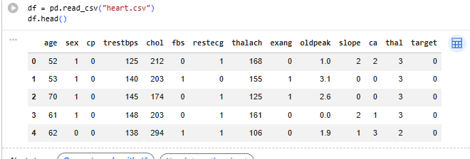

4. Methodology
- Imported dataset
- Performed train-test split (80:20)
- Trained Logistic Regression model
- Predicted test results
- Evaluated using performance metrics

5. Evaluation Metrics Explanation
- Accuracy: Overall correctness of model
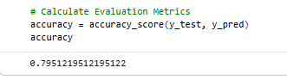
- Precision: How many predicted positives are correct
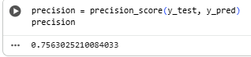
- Recall: How many actual positives are captured
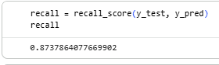
- Confusion Matrix: Breakdown of correct & incorrect predictions
- 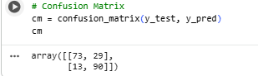

6. Results

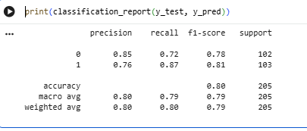

7. Conclusion
The Logistic Regression model successfully predicts heart disease with acceptable accuracy. Evaluation metrics show the model’s effectiveness in identifying positive cases.

